**7.) Test the mobile responsiveness of a website or application. This might involve testing the website or application on different devices and screen sizes, and verifying that the layout and functionality are consistent across all devices.**

**Screen size for mobile web application:**

Google chrome at the mobile screen.

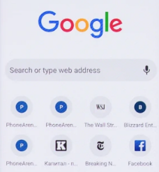

**Screen size for desktop web application:**

Google chrome at desktop size view.

